**TYPE:** Test

**TASK 13: DNA & Cell Division Test (88 marks)**

Students will complete a number of questions relating to DNA and cell division. These questions will address specific content as well as analysis of second-hand data. This task will be completed in one session under test conditions.

**Time for the tasks (1 hour)**

* 5 minutes reading time
* 55 minutes working time

**What you need to do:**

* Follow the instructions provided very carefully to complete the test.
* Draw any results in pencil and answer all questions given.
* It is your responsibility to organise your time effectively.
* There is to be no discussion between you or any of your class mates.
* No sharing of any equipment or answers at all.

|  |  |  |  |
| --- | --- | --- | --- |
| SECTION | Question Type | Marks Available | Your marks |
| A | Multiple Choice | 20 |  |
| B | Short Answer | 52 |  |
| C | Extended answer | 16 |  |
|  | TOTAL | 88 |  |

DO NOT TURN THIS PAGE OVER UNTIL YOU ARE TOLD TO

**STUDENT NAME: __________________________________________________________________**

**TEACHER: Mrs Cunningham YEAR: 11**

**DNA & CELL DIVISION TEST**

**PART A: Multiple choice questions.**

**Please mark your answers in the answer sheet provided and NOT on the questions.**

1. If 40% of the nucleotides in a sample of DNA contains adenine, what percentage of the sample contains the nucleotide cytosine
2. 40%
3. 60%
4. 20%
5. 10%
6. Where in human cells is DNA located?
7. In the nucleus.
8. In the nucleus and in the mitochondria.
9. In the nucleus and in the ribosomes.
10. In the nucleus and in the Golgi body.
11. DNA is a double-stranded nucleic acid, which forms our chromosomes. In a normal chromosome, which of the following is CORRECT?
12. The number of Guanine bases is equal to the number of Cytosine bases.
13. The number of Thymine bases is twice the number of Cytosine bases.
14. The total number of all four bases is equal.
15. The number of Adenine and Uracil bases is equal.
16. During cell division, the DNA molecule replicates itself. The reason for this is so:
17. if the cell makes a mistake there is enough DNA to go around
18. the daughter cells end up with the same genetic information as the parent cell
19. the DNA can move out of the nucleus into the cytoplasm
20. there are enough chromosomes for each cell produced

5. What is the urethra?

a. the entrance to the uterus

b. channel which carries semen and urine through the penis to the outside of the body.

c. passage way of sperm cell

d. where the ovum is fertilised

6. Below is a photomicrograph showing a baby's chromosomes in what is called a karyotype.

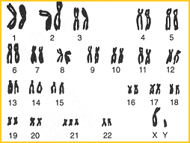

The chromosomes shown above are not always visible. What is the first stage of the cell cycle in which they be seen?

1. Interphase
2. Prophase
3. Metaphase
4. Telophase

7. Two cells which are the products of mitosis

* 1. have identical genetic potential
  2. will develop identically
  3. have different chromosome numbers in each cell
  4. contain chromosomes that are not duplicated

1. During which of the following stages of the mitotic cycle can the arrangement of chromosomes at the

equator of the spindle be observed at a cell?

1. Prophase
2. Interphase
3. Telophase
4. Metaphase
5. A DNA molecule may be made using which of the following?

1. uracil 2. adenine 3. thymine 4. guanine 5. cytosine

* 1. *1, 2, 3, 4*
  2. *2, 3, 4, 5*
  3. *1, 3, 4, 5*
  4. *1, 2, 3, 4*

1. If you were examining a sequence of base pairs in a DNA molecule, which sequence would be

possible in a properly constructed double-stranded DNA molecule?

* 1. A+T, C+G, T+A, T+A, G+C
  2. A+T, G+C, C+C, T+U, G+T
  3. G+C, C+G, A+U, U+A, T+A
  4. G+G, C+C, A+A, T+T

1. What do you call a cell's genetic material during a non-dividing phase?
   1. chromatid
   2. RNA
   3. chromosome
   4. chromatin
2. A DNA molecule is bound to special proteins that assist them coil into a smaller area. These proteins

are called:

* 1. nucleotides
  2. Chromatin
  3. Genes
  4. histones

1. Messenger RNA leaves the nucleus and attaches to a
   1. Ribosome
   2. Golgi apparatus
   3. Mitochondrion
   4. Cell membrane
2. Which of the following processes does the DNA molecule go through during interphase?
   1. transfer
   2. replication
   3. termination
   4. destruction
3. Which of the following is in the correct order for the main stages of mitosis?

a. prophase, metaphase, anaphase then telophase.

b. metaphase, prophase, anaphase then telophase

c. prophase, anaphase, metaphase then telophase

d. prophase, metaphase, telophase then anaphase

16. A protein is made up of:

1. simple sugars.
2. Fatty acids
3. glycerol
4. amino acids.

17. Vas deferens are:

a. a muscular tube that passes upward alongside the testes and transports semen

b. sperm storage organ

c. ovum holding area

d. where sperm are produced

18. After the sperm meets the egg

a. the uterus sheds its lining

b. the successful sperm dies

c. the ovary releases two more eggs

d. the fertilized egg implants in the wall of the uterus.

19. Normal fertilization usually takes place in the:

a. uterus

b. oviduct

c ovary

d vagina

20. In meiosis, the number of gametes which result from the original cell is

a. 16

b. 4

c. 23

d. 46

END OF MULTIPLE CHOICE SECTION

PART B: Short Answer questions. (58 marks)

Please write your answers in the spaces provided on this sheet.

21. Match each item with the correct description below by writing the number of the description next to the letter of each item below.

____ a. scrotum ____ e. cervix

____ b. sterility ____ f. erection

____ c. vulva ____ g. menstruation

____ d. uterus ____ h. penis

Description:

1 inability to produce offspring

2. a loose sac of skin which holds the testes

3. a hollow muscular organ that receives and holds a fertilized ovum

4. the opening to the uterus

5 a male organ which is used for sexual reproduction and elimination of body wastes

6. the external female reproductive organs

7. the process of shedding the lining of the uterus

8. when the sponge-like tissues of the penis fill with blood and it becomes enlarged and hard

(8 marks)

22. Below is a diagram of a small section of DNA

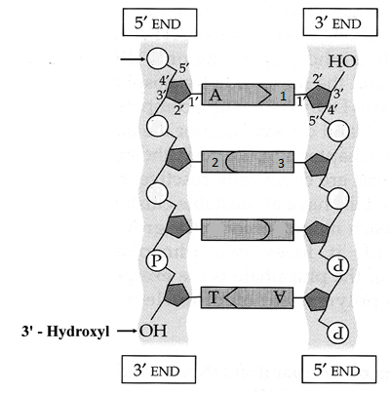

4

1. Structure A is a nitrogen base called adenine. Name the nitrogen bases labelled 1, 2 & 3.

1:

2:

3: ______

(3 marks)

1. Name the term used to describe structure 4 (indicated parts in the box) and identify the two other molecules (besides the nitrogen base) that make up this structure.

(3 marks)

1. Explain how the process of DNA replication allows daughter cells to receive DNA copies that are exactly the same as the parent cell’s DNA.

(3 marks)

23. Describe one major event for each of the phases of mitosis.

|  |  |
| --- | --- |
| **Phase** | **Events** |
| Prophase |  |
| Metaphase |  |
| Anaphase |  |

(3 marks)

24. Compare and contrast [3 differences/similarities between] RNA and DNA. Fill in the table below.

|  |  |  |
| --- | --- | --- |
| Characteristic | DNA | RNA |
|  |  |  |
|  |  |  |
|  |  |  |

(3 Marks)

25. Explain why the process of mitosis is essential to growth in organisms (e.g. Humans).

(2 Marks)

26. List 4 causes of cancer.

(4 Marks)

27. Early detection is critical for the successful treatment of cancer. Describe one procedure which is used to detect the presence of cancer. (Name the cancer and describe the procedure)

(3 marks)

28. The male reproductive system

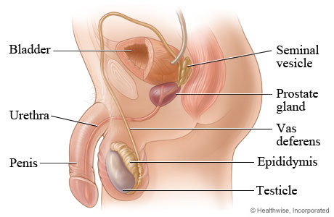

A

B

F

C

D

E

1. The diagram above illustrates the male reproductive system. Name the structures labelled;
   * 1. **A _______________________________________________**
     2. **B _______________________________________________**
     3. **C _______________________________________________**
     4. **D _______________________________________________**
     5. **E _______________________________________________**
     6. **F _______________________________________________**

[6 marks]

1. Which structure produces the hormone responsible for male secondary sex characteristics?

_____________________________________________________________________

[1 mark]

1. What is the function of E?

_____________________________________________________________________

[1 mark]

1. Through which structure do sperm leave the body?

_____________________________________________________________________

[1 mark]

e. What problem can be associated with structure B?

_____________________________________________________________________

[1 mark]

29. The female reproductive system

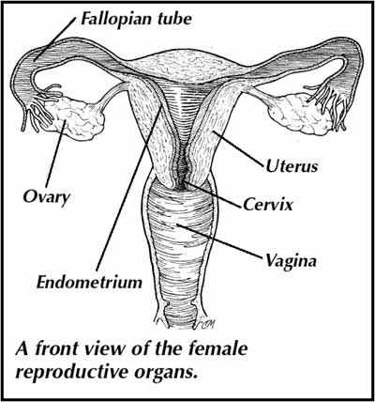

A

C

B

E

D

F

1. The diagram above illustrates the female reproductive system. Name the structures labelled;
   * 1. **A _______________________________________________**
     2. **B _______________________________________________**
     3. **C _______________________________________________**
     4. **D _______________________________________________**
     5. **E _______________________________________________**
     6. **F _______________________________________________**

[6 marks]

1. Where is fertilisation most likely to occur in the female reproductive system?__________________________________________________________ [1 mark]

1. Explain the role of structure F

_____________________________________________________________________

.

____________________________________________________________________[2 marks]

1. What is the approximate lifespan of the ovum after ovulation has taken place?

_____________________________________________________________________

[1 mark]

END OF SHORT ANSWER CHOICE SECTION

PART C: Extended Answer questions. (16 marks)

30 a. Discuss the importance of proteins in the human body by naming 2 different proteins and their function. (6 marks)

______________________________________________________________________________

______________________________________________________________________________

______________________________________________________________________________

______________________________________________________________________________

______________________________________________________________________________

______________________________________________________________________________

______________________________________________________________________________

______________________________________________________________________________

______________________________________________________________________________

______________________________________________________________________________

______________________________________________________________________________

______________________________________________________________________________

______________________________________________________________________________

______________________________________________________________________________

______________________________________________________________________________

______________________________________________________________________________

______________________________________________________________________________

______________________________________________________________________________

______________________________________________________________________________

______________________________________________________________________________

______________________________________________________________________________

______________________________________________________________________________

______________________________________________________________________________

______________________________________________________________________________

30 b. Describe in detail the process of protein synthesis. (10 marks)

______________________________________________________________________________

______________________________________________________________________________

______________________________________________________________________________

______________________________________________________________________________

______________________________________________________________________________

______________________________________________________________________________

______________________________________________________________________________

______________________________________________________________________________

______________________________________________________________________________

______________________________________________________________________________

______________________________________________________________________________

______________________________________________________________________________

______________________________________________________________________________

______________________________________________________________________________

______________________________________________________________________________

______________________________________________________________________________

______________________________________________________________________________

______________________________________________________________________________

______________________________________________________________________________

______________________________________________________________________________

______________________________________________________________________________

______________________________________________________________________________

______________________________________________________________________________

______________________________________________________________________________

______________________________________________________________________________

______________________________________________________________________________

______________________________________________________________________________

______________________________________________________________________________

______________________________________________________________________________

______________________________________________________________________________

______________________________________________________________________________

______________________________________________________________________________

END OF TEST